**SYSTEM ENGINEERING FOR ELECTRIC DOORBELL**

Principles of System Engineering (INSE-6400)

Project Proposal

Masters of Information Systems Security (MEng)



Submitted by:

|  |
| --- |
| Bharani Shankar Ede 40161404 |
| Sri Harsha Bhavaraju 40185400 |
| Jitendra Pasula 40183192 |
| Sai Krishna Kodati 40156109 |
| Venkata Srisuma Ganji 40167281 |
| Makineni sai manoj 40162306 |

**Submitted to :**

Dr. Ayda Basyouni

**Introduction:**

* In today's world, automatic security systems are preferred over manual systems. A smart electric doorbell system is such an Internet of Things (IoT) device that can be controlled remotely. In addition to this, smart electric doorbell systems are well efficient in providing suitable security solutions to homes as well as organizations.
* A general description of the developed electric doorbell system has been made. Customers to apply this smart electric doorbell system at their houses have done a brief description of the developed system within this assignment while stating the possible needs
* ***Electric doorbell*** maintains the control features within home appliances through remote sensing software. Based on the server system the application features are adjusted to connect the database profile

**CUSTOMER NEEDS IDENTIFICATION:**

|  |  |  |  |
| --- | --- | --- | --- |
| No | Customer requirement | Description | Weight |
| 1 | Steady connection | This smart electric doorbell system must be able to provide a steady connection while sending notification to the owners of the house in real time. | 0. |
| 2 | Long range | Must have a long operation range. | 0. |
| 3 | Tracking system | Must be able to track the presence of visitors as well as someone breaking into the house. | 0. |
| 4 | Ease of access | Large buttons, visible led lights, can be used remotely. | 0. |
| 5 | Ease of installation | Easy and quick installation |  |

**IDEA OF ELECTRIC DOOR BELL:**

**Motion Sensor:** PIR's are the most commonly utilized type of sensor in motion detectors and security systems, as they are some of the most reliable when it comes to detecting motion in the room or area where they are placed

**Webcam :** The Nest Doorbell (battery) gets almost everything right. Its 3:4 vertical aspect ratio means you can see more of your front door; it can work either wired or on battery power alone, and it has a lot of great features, such as the ability to recognize familiar faces, packages, animals, and vehicles

**Face recogination :** The Kami Doorbell Camera is a smart video doorbell that combines facial recognition features with advanced artificial intelligence to enhance safety, security and peace of mind at home.

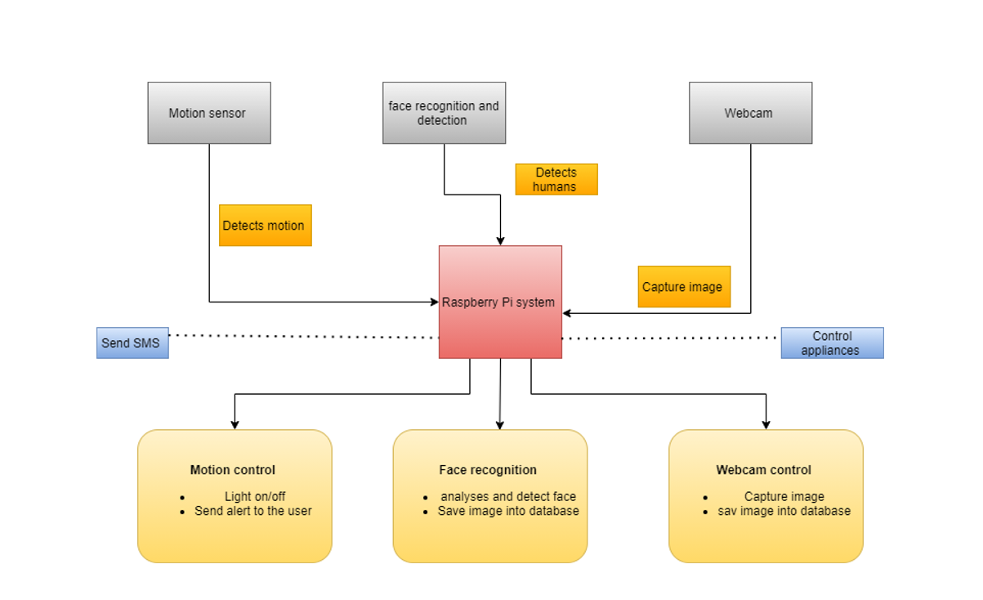

**Research on mini computers:**

We have done research on various mini computers for using in the system electric bell

* **Onion Omega2+:** The Onion Omega2+ is one of the cheapest IoT (Internet of Things) single board computers with a Linux Operating System and built-in WiFi. It is designed in a way that users of all skill levels can build their hardware applications. Plugging Omega boosts the operating system immediately, and one can start developing in their programming language or create web applications.
* **Banana Pi M3:** The Banana Pi M3 has an Octa-core processor with a PowerVR GPU and 2GB RAM. An open platform device is ideal for people who want to learn and create projects with developer technology. It has a built-in microphone and IR receiver and power and reset buttons
* **Raspberry Pi :** The Raspberry Pi 4 has dual-screen functionality as its dual Micro-HDMI ports allow users to connect two display monitors to it. The Pi also includes 4K 60 fps decoding features where as The Odroid XU4 enables a single HDMI 1.4a connection at 1080p output.

**Odroid XU4:** The Odroid XU4 has powerful and energy-efficient hardware with octa-core Heterogeneous Multi-Processing ARM CPU and 2GB of RAM. It is built around a Samsung Exynos5422 SoC and has an HDMI 1.4 supporting 1080p output, 3 USB ports, Gigabit Ethernet, and a 30-pin GPIO header. It can run a full desktop version of Ubuntu and supports Android and has a power button included.

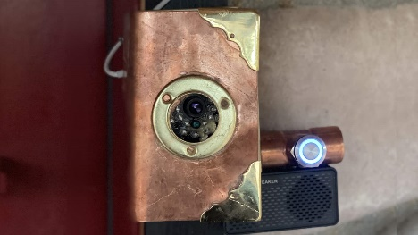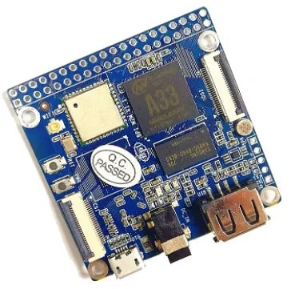

**Trade off matrix:**

??

**Feasibility analysis:**

* we compared mini computers and finally we selected raspberry pi as shown in the below features.
* Operational feasibility - Arduino is microcontroller board, while Raspberry Pi is a microprocessor based mini computer (SBC). ... Raspberry Pi SBC has all features of a computer with a processor, memory, storage, graphics driver, connectors on the board. Raspberry Pi needs an Operating System to run
* Technical feasibility - To start things off, the Omega2 offers a 580 MHz CPU, 16 MB worth of storage and 64 MB of RAM. Meanwhile, the Pi Zero triumphs over it with a 1 GHz CPU plus 512 MB of RAM.
* Economic feasibility - A Raspberry Pi 4 (1 GB) starts at approximately $35 and the Odroid XU4 is priced at ~$50

**What have you achieved so far?**

* Trade off matrix for evaluating design alternatives.
* Customer need survey about the electric doorbell.
* Feasibility Analysis on our electric doorbell

**What are the problems you are facing:**

* After analysing the feedback gathered from the customers, following deficiencies within this electric doorbell system have been identified as well reviewed.

*Lack of uninterrupted connection*

* This current electric doorbell system uses a router to make communication between the owner and visitors.
* Any disturbance in router communication can results in interrupted connection.

*Lack of tracking facility in real time*

* Though this system has been enabled with sensor devices, however an issue with cloud storage can result in delay of tracking the visitor as well as notifying the owner in real time.

**How are you planning to continue?**

* smart electric doorbell systems have been consistent with several hardware as well as software devices. Hence Hardware that will be utilized within this smart electric doorbell system is mainly consistent with Raspberry Pi and GSM module
* So we are planning to learn more about raspberry pi and GSM module and to use in our electric door bell
* We are planning to work on hardware devices such as sensors, webcam and face recognition devices.
* We are working on software requirements for the electric doorbell. The raspberry pi will use a webcam (attached to it) to take pictures at stand still in which my code will process-An lcd screen attached to the raspberry pi will display data such as time, webcam specs etc.-After the processing, it will save the data onto a memory card also attached to the webcam

**Roles of team member:**

* Manoj and Harsha –we worked on ideas on electric bell and worked on comparing mini computers with raspberry pi
* Bharani and Jitendra- We worked on customer Need identification and trade off matrix for electric door bell
* Suma and Sai Krishna – We worked on Feasibility analysis in depth. We compared economy, technical and operational feasibility.